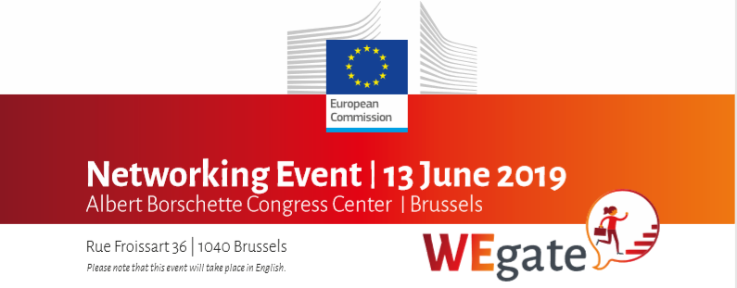

What have we learned during our WEgate event ?

Main Outcomes

- If you have an idea and find something that it important to you, take the leap! Always go for good mentors! A good social support network is also key! If one dreams big enough, has a good mentor and access to finance, one will succeed!

- All SMEs need access to capital and a suitable regulatory framework. But when starting a business, women entrepreneurs face more challenges than men. This is why we need to make sure that successful role models of female entrepreneurs are visible.

- When starting their own businesses, women want to speak to women, to share their entrepreneurial ideas and their challenge, including how to scale-up.

- In order to succeed, female entrepreneurs should be able to go beyond their comfort zone and speak to stakeholders outside their communities.

- WEgate: Prospects for the future

- WEgate provides a good basis for building a network of women entrepreneurs and support organizations. However, the platform has to be modified to achieve this objective.
- WEgate needs a face – a dedicated secretariat, which is more than a technical team. There has to be ownership and representation on the ground to serve as WEgate ambassadors and feed information between all levels.
- WEgate needs a communication strategy. It has to be present in all social media and become visible. The platform also needs a strong brand identity.
- WEgate should work with local female entrepreneurs associations – providing all their contacts on the platform, but also enabling synergies.
- WEgate community building needs face-to-face meetings in order to thrive.
- WEgate should enable information sharing, facilitate trainings and provide training materials online. It should also connect mentors with existing and would-be entrepreneurs.
- WEgate should create business opportunities for entrepreneurs through matchmaking.

- Obtaining Financing, Mentoring and Training

- There are many financing opportunities out there, but the information about them is limited.
- When pitching to banks and investors, a mindset change is necessary, both for women entrepreneurs and for those receiving the pitches.
- We need to better encourage and promote practices that have worked in Europe.
- It is important to inform and encourage VCs to invest in women and share examples, as well as give more visibility to successful VCs.
- Women entrepreneurs are more often socially involved and thus are more keen on providing mentoring. More information is needed on where and how to find a relevant mentor.

